REPORT ON APPLYING CRYPTOGRAPHY IN REAL WORLD SCENARIO
INTRODUCTION
Cryptography plays a critical role in modern cybersecurity by ensuring that data remains secure from unauthorized access, modification, and impersonation. This project focused on the practical application of cryptographic techniques using OpenSSL to simulate real world data protection scenarios. The project involved implementing encryption, decryption, hashing, and public-key cryptography to protect data confidentiality, integrity, and authenticity.
2. Aim and Objectives
Aim
The aim of this project is to demonstrate the practical application of cryptography in securing data, ensuring confidentiality, integrity, and authenticity in real world scenarios using industry relevant tools..
Objectives
- To demonstrate symmetric encryption using AES
- To verify data integrity using cryptographic hashing(SHA-256)
- To implement asymmetric encryption(RSA), using public and private keys
- To understand how cryptography protects real world systems
3. Concept of the Project
Cryptography is a core component of cybersecurity used to protect information from unauthorized access, modification, or impersonation.
This project focuses on three main cryptographic concepts:
- Confidentiality – ensuring data is readable only by authorized parties
- Integrity – ensuring data is not altered during storage or transmission
- Authenticity – ensuring the identity of the sender or owner of data
Using OpenSSL, real files were encrypted, decrypted, hashed, and verified to simulate real world security scenarios such as secure file storage and secure message exchange.

4. Tools Used
The following tools were used to carry out this project:
- OpenSSL – for encryption, decryption, hashing, and key generation
- Windows Command Prompt – for executing cryptographic commands
- Text Editors (Notepad / Microsoft Word) – for creating and modifying files

5. Methodology (Steps Taken)
The project was carried out in three major stages:
5.1 Symmetric Encryption (AES)
Description
Symmetric encryption uses the same password/key for both encryption and decryption. AES (Advanced Encryption Standard) was used to encrypt a plaintext file.
Procedure
1. plaintext file (secret.txt) was created containing sample text
2. The file was encrypted using AES-256-CBC via OpenSSL
3 .The encrypted file was then decrypted using the same password
4. The decrypted output was compared with the original file to confirm accuracy
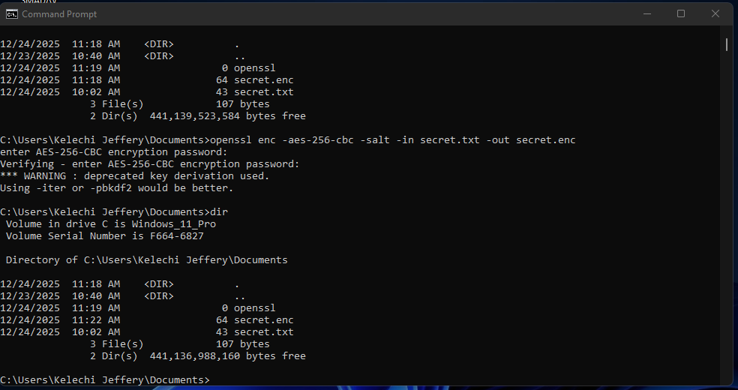
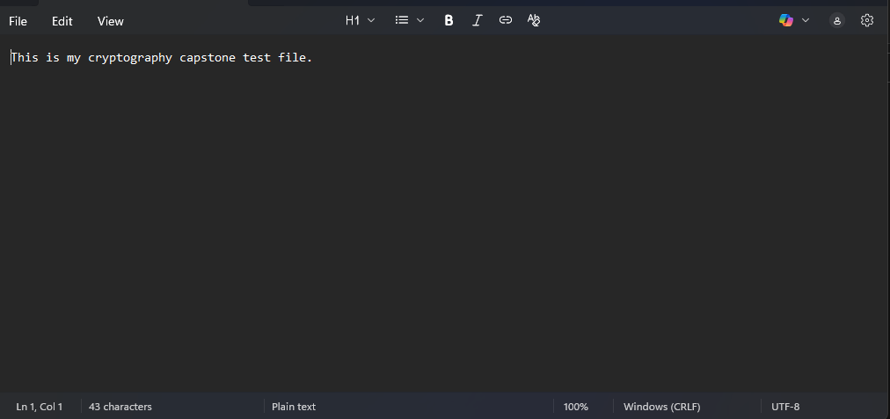
Plaintext file before encryption

AES encryption command executed in OpenSSL

x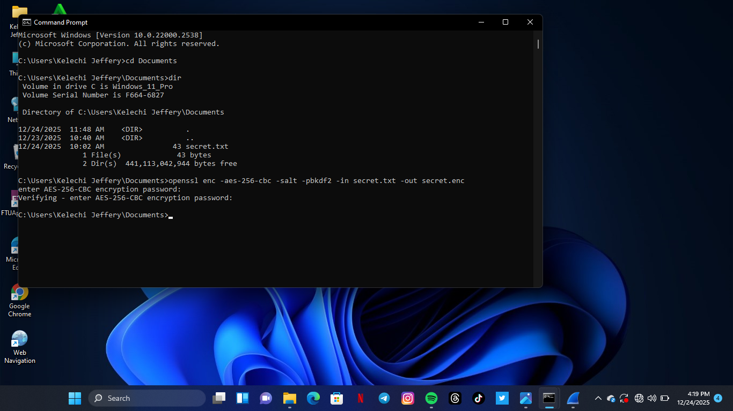
AES encryption command executed in OpenSSL
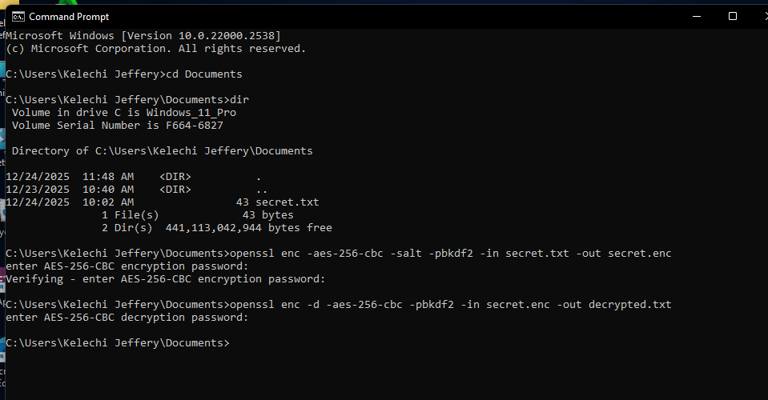

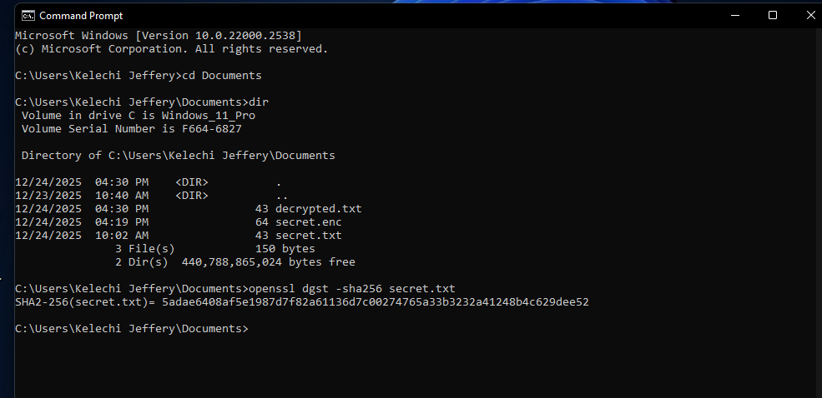
Successful decryption of the encrypted file

5.2 Hashing and Integrity Checking (SHA-256)
Description

Hashing is used to verify data integrity. A hash value uniquely represents the contents of a file. Any modification to the file results in a completely different hash.
Procedure
1. A SHA-256 hash was generated for the original file
2. The file was modified slightly
3. Anew hash was generated
4 The two hash values were compared to demonstrate integrity checking
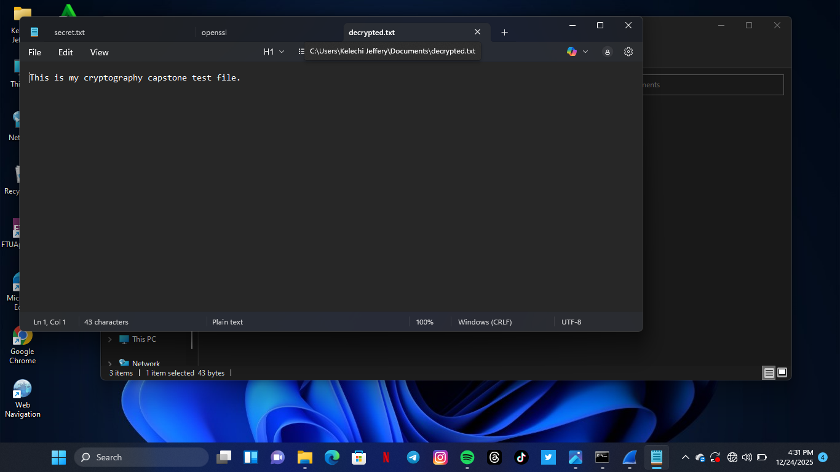
The hash value of the original file

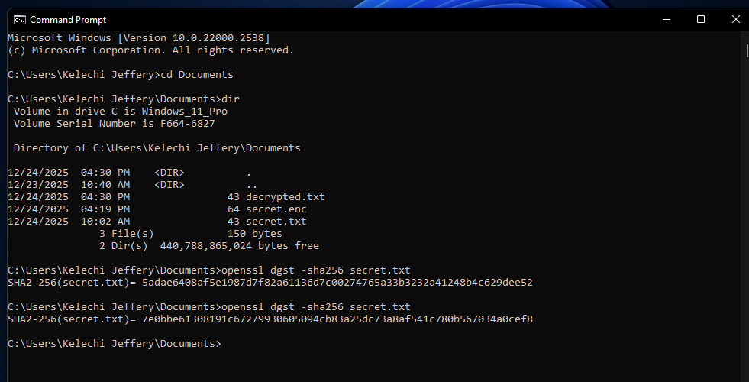
Modified file hash showing a different value

5.3 Asymmetric Encryption (RSA)
Description
Asymmetric encryption uses two keys:
- A public key for encryption
- A private key for decryption
This method is commonly used for secure communication and key exchange.
Procedure
1. A private and public key pair was generated using OpenSSL
2. A message file was encrypted using the public key
3. The encrypted message was decrypted using the private key
Successful decryption confirmed secure communication
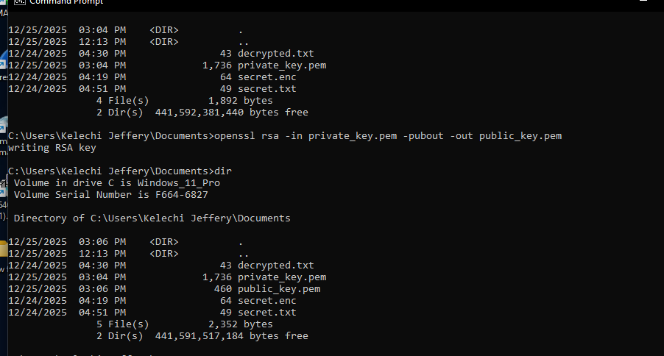
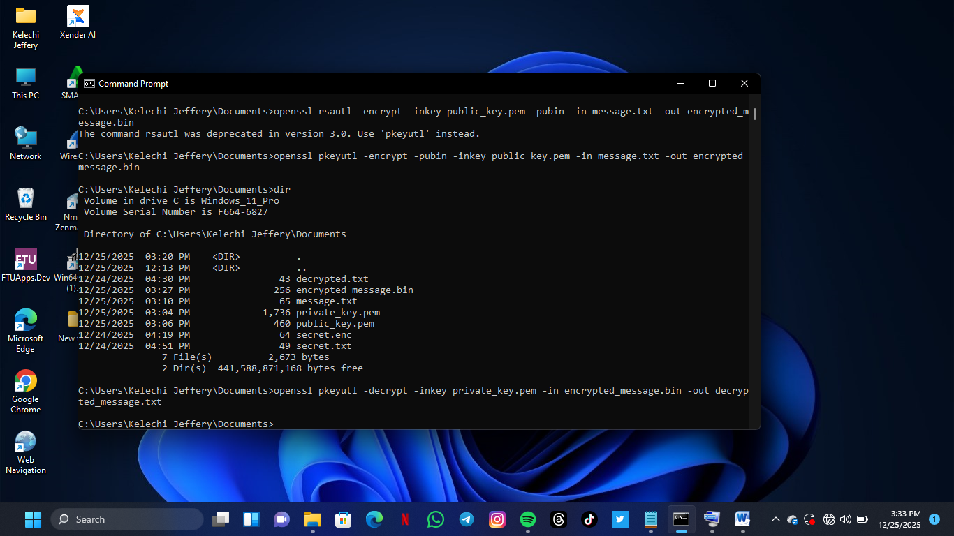
Creation of public key
Creation of private key
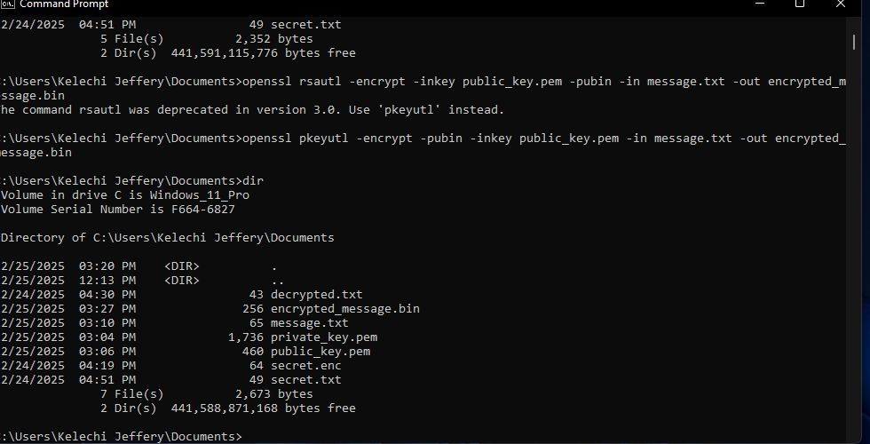
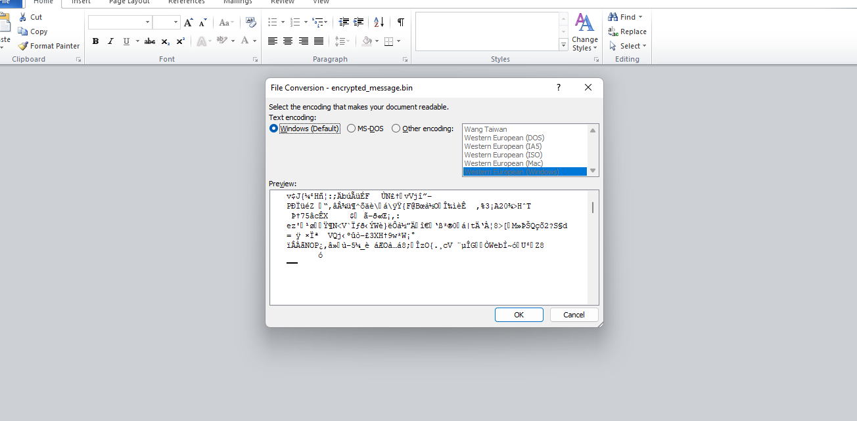

ENCRYPTION USING PUBLIC KEY

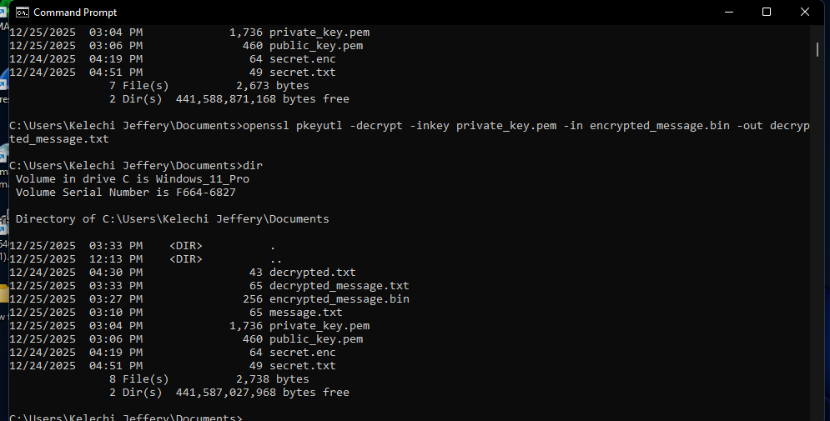
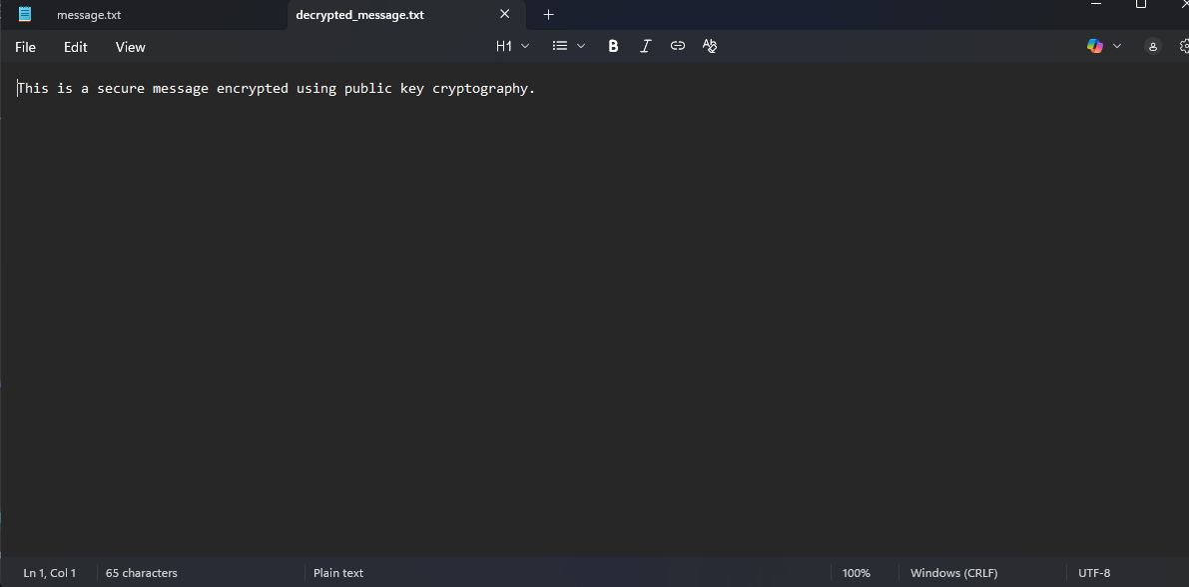

DECRYPTION USING PUBLIC KEY

6. Results / What Was Achieved
Files were successfully encrypted and decrypted using symmetric encryption
File integrity was verified using hashing
Secure message exchange was demonstrated using asymmetric encryption
The project successfully showed how cryptography protects data in real world systems

7. Challenges Encountered and Solutions
Challenge 1: OpenSSL not recognized as a command
Initially, OpenSSL commands returned errors indicating that the command was not recognized.
Solution: This was resolved by reinstalling OpenSSL and ensuring it was properly added to the system PATH.

Challenge 2: File and directory path errors
Errors occurred when OpenSSL could not locate required files.
Solution: The issue was resolved by navigating to the correct directory using the cd command and ensuring all files were stored in the same folder.
Challenge 3: Deprecated RSA commands
Warnings were encountered indicating that some RSA commands were deprecated.
Solution: The recommended pkeyutl command was used instead to maintain compatibility with newer OpenSSL versions.

Challenge 4: Encrypted files appearing unreadable
Encrypted files appeared blank or unreadable when opened normally.
Solution: This was understood to be expected behavior, as encrypted files are stored in binary format.

8. What I Learned
Through this project, I gained practical understanding of:
- How encryption protects data confidentiality
- How hashing detects file tampering
- How public and private keys enable secure communication
- How real world cryptographic tools are used in cybersecurity operations
- This project strengthened both my technical skills and problem solving ability..

9. Conclusion
This project successfully demonstrated the real world application of cryptography using OpenSSL. By implementing encryption, hashing, and public key cryptography, the project highlighted how data confidentiality, integrity, and authenticity are achieved in modern systems. The hands on experience provided a strong for understanding cryptographic security in practice.

10. References
OpenSSL Documentation
NIST Cryptographic Standards
TechCrush Cybersecurity Training Materials

